There are two simple ways to build a DIY incubator:

1. The Simple Way
2. The Arduino Way

The Simple Way

1. Purchase a cooler or styrofoam container
2. Heat up a tuperware container that contains water, close it and put it in the closed container.

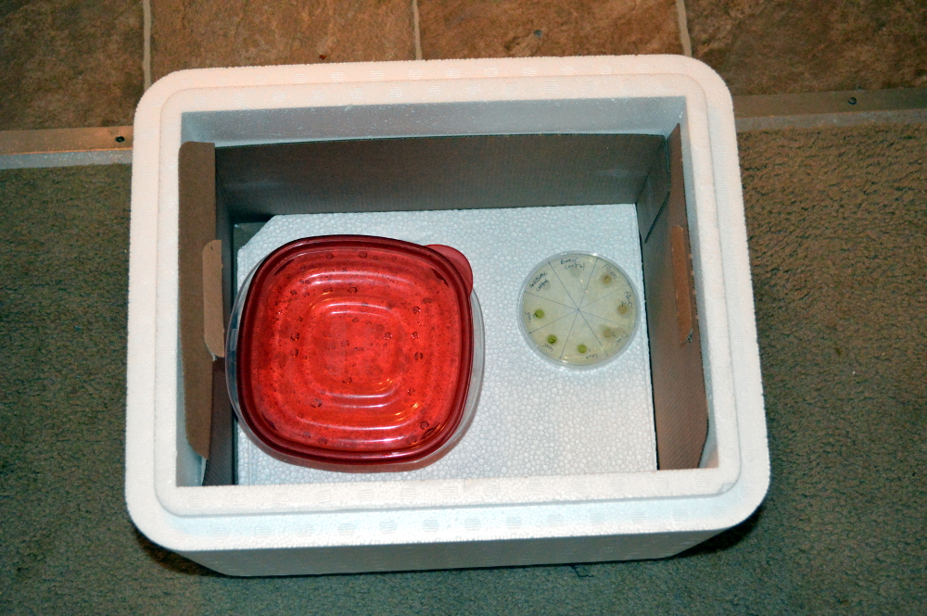

The Arduino Way

1. You need a cooler or styrofoam container or something to keep the temperature contained and insulated.
2. You can purchase this kit (<http://www.the-odin.com/build-your-own-temperature-regulated-incubator/>)
3. Or You can purchase the kit contents yourself and build something similar. Basically, all you need is a way to generate heat and a container.